Lab 8 7/31/2017
Nyquist Criteria
Plot L1
$L_{1}(s)$= $\frac{1}{(s+1)(s-2)}$
Distrubuted Denominator = $s^{2}-s-2$
Pole/P = -1, 2
N = 0
Unstable System
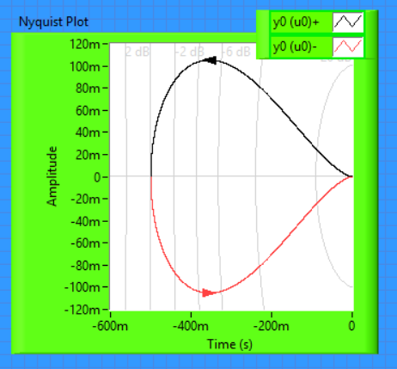
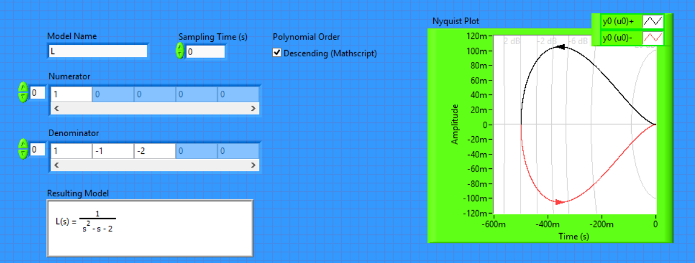

Figure 1.
Plot L2
$L_{1}(s)$= $\frac{2}{(s+1)(3s-1)}$
Distrubuted denominator = $3s^{2}+2s-1$
Pole = 1/3,-1
N = 1
Stable System
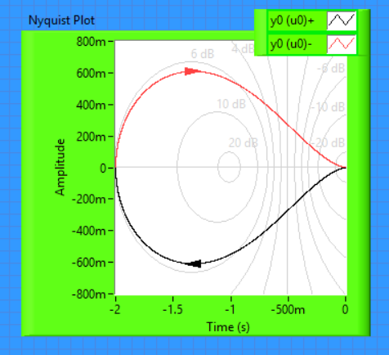
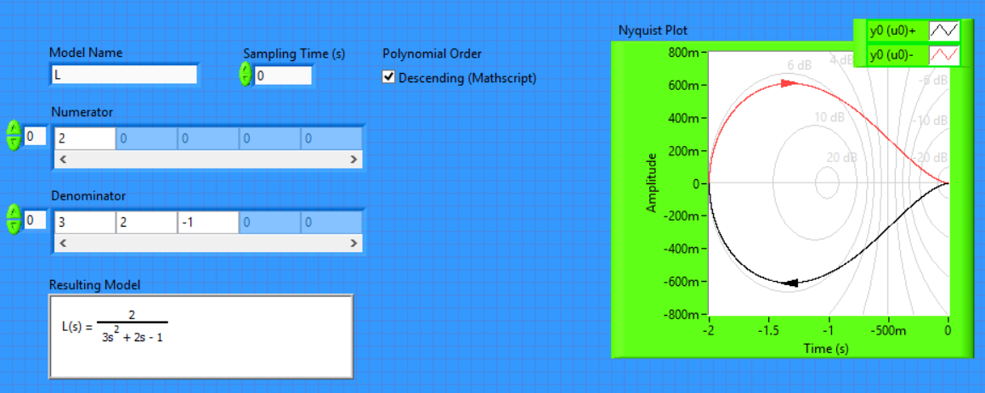

Figure 2.

Plot L3
$L_{1}(s)$= $\frac{1}{(s+1)(s-3)}$
Distrubuted denominator = $s^{2}-2s-3$
Pole = 3,-1
N = 0
Unstable System
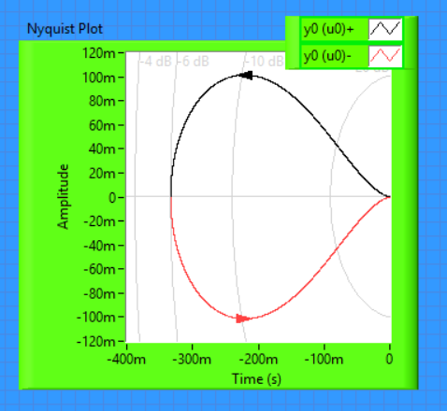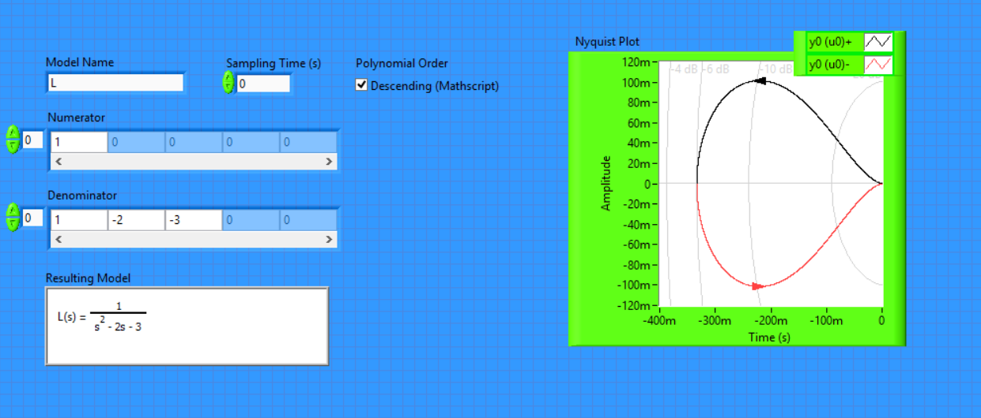

Figure 3.

Plot L4
$L_{1}(s)$= $\frac{1}{(s+1)(s+4)}$
Distrubuted denominator = $s^{2}-5s-4$
Pole = -1, -4
N = 0
Stable System
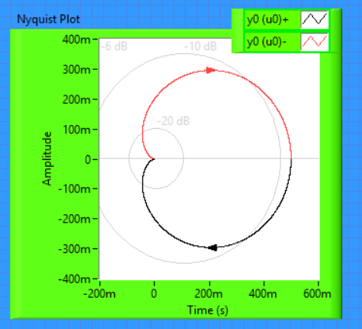
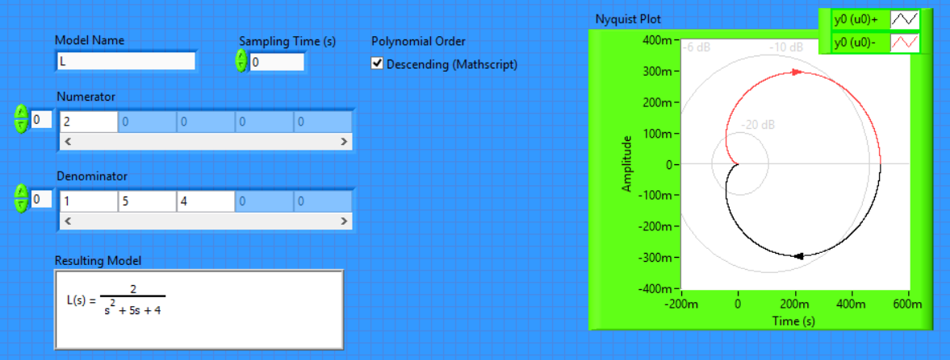
Figure 4.

I found this case interesting because even though that system is stable it has two poles that are negative values.

